**Assignment No: 5**

1. Draw level 0 , level 1 and level2 DFD for your project
2. Draw ER diagram for your project.
3. Draw Structure chart for your project.

E:\SAD\levelodfd.png

**Level 0 DFD**:-

**Level1 DFD:-**

E:\SAD\lev.png

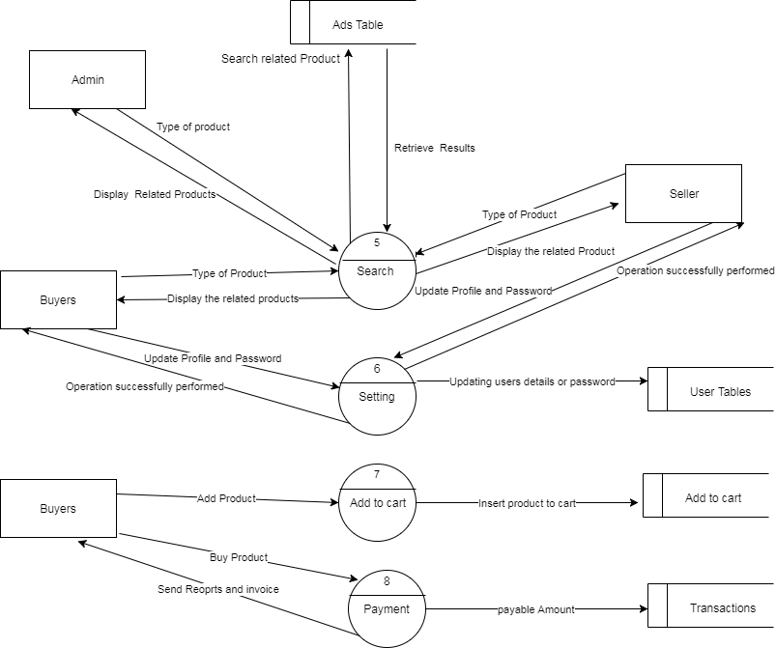

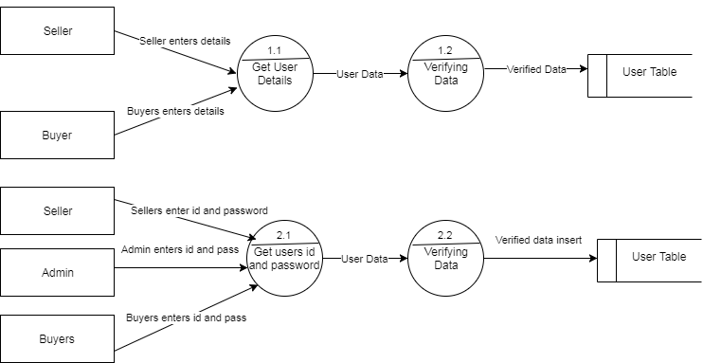**Level 2 DFD:-**

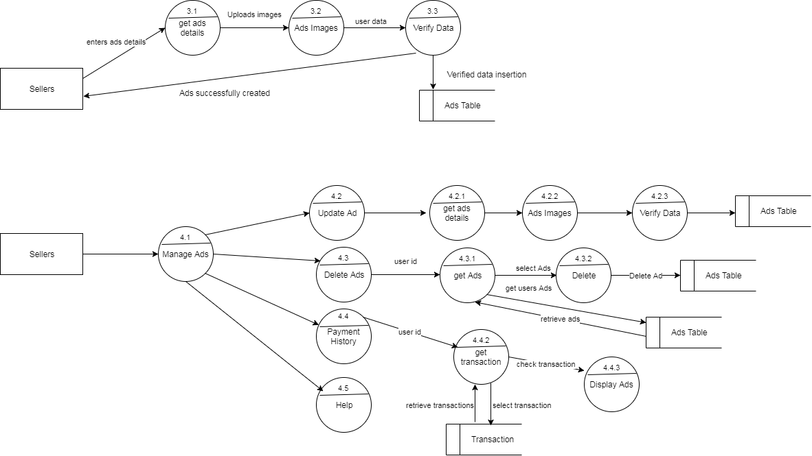

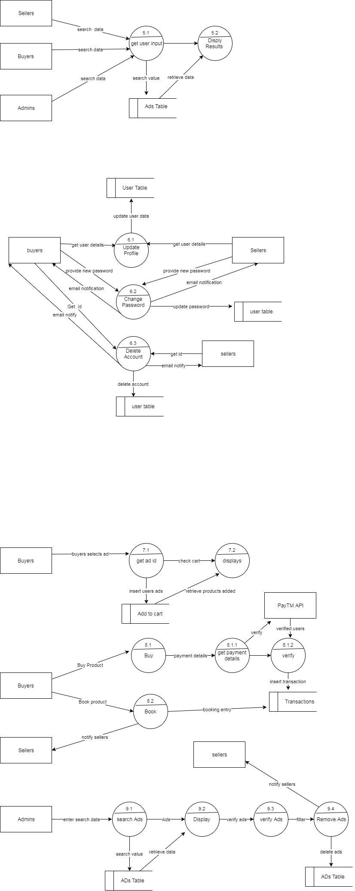

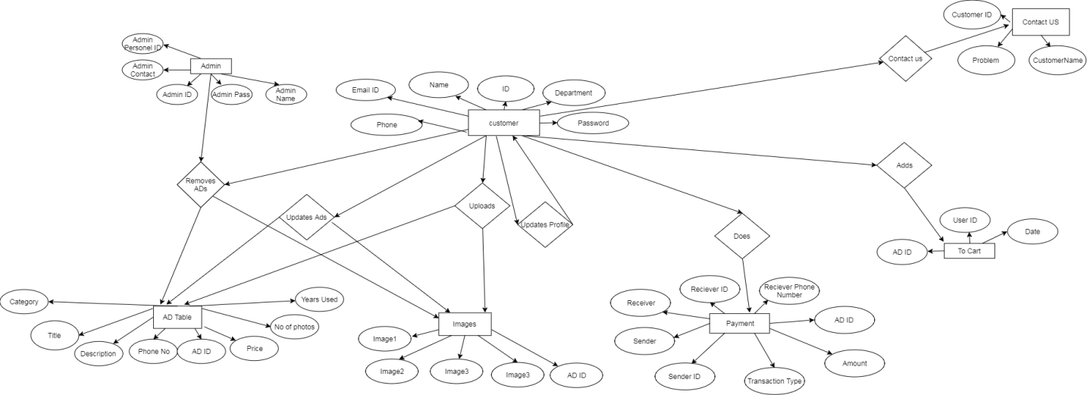**ER Diagram:-**

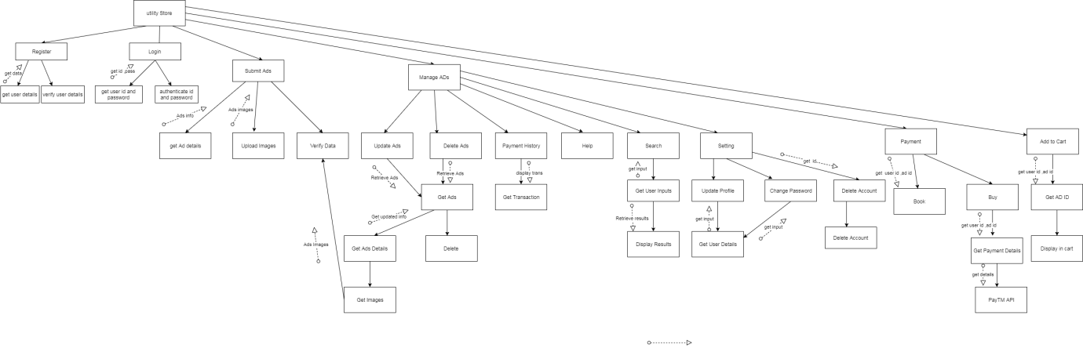**Structure Chart:-**